CS 305 Module Two Coding Assignment
Draven Chen | CS 305: Software Security | Southern New Hampshire University

Run Dependency Check

I integrated the OWASP dependency-check Maven plug-in (version 12.0.2) into the Module 2-2 Spring Boot project and ran the check goal against the resolved dependency graph. The plug-in matched each JAR to Common Platform Enumeration (CPE) identifiers and cross-referenced them against the National Vulnerability Database. The figures below are from the HTML report written to target/dependency-check-report.html.
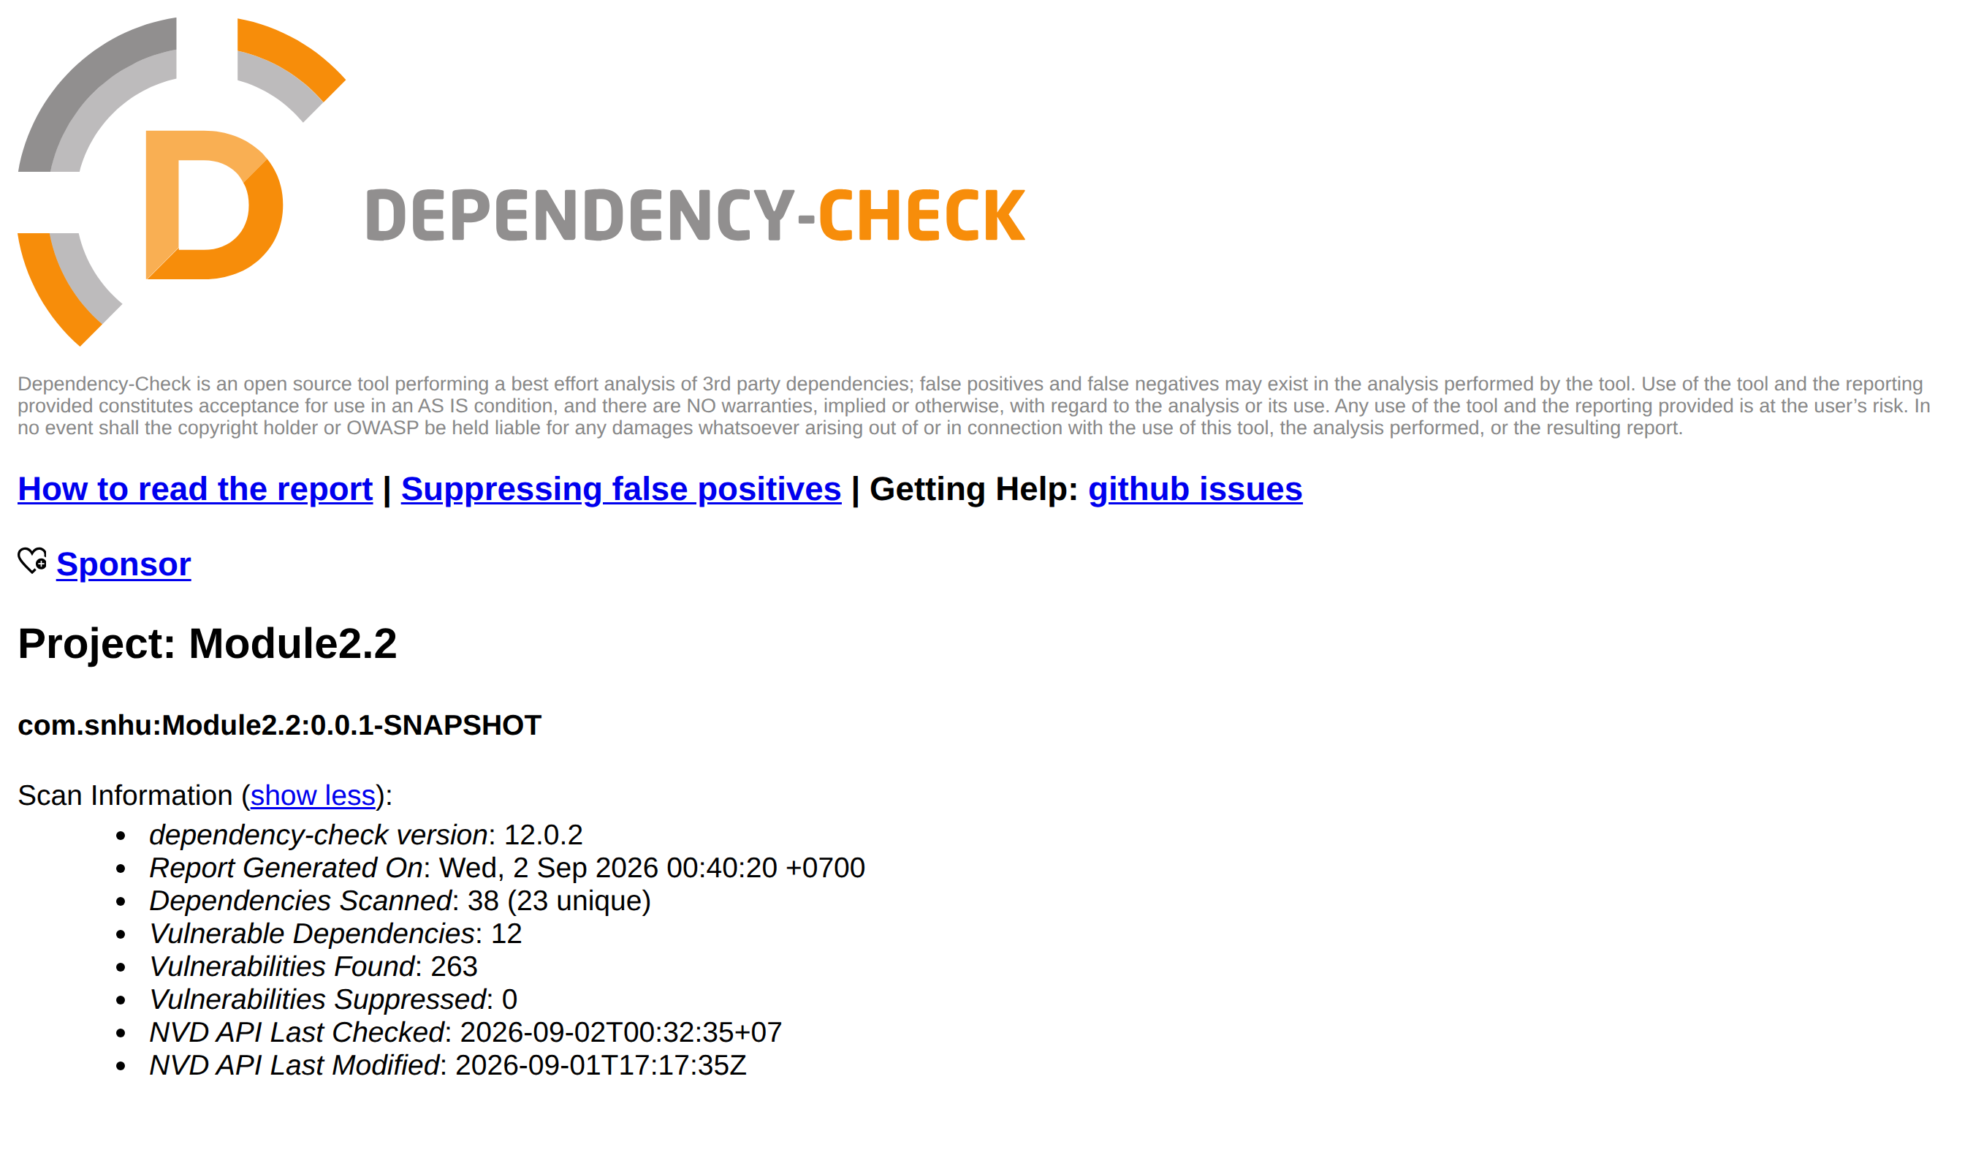
Figure 1. Scan information from the dependency-check report.
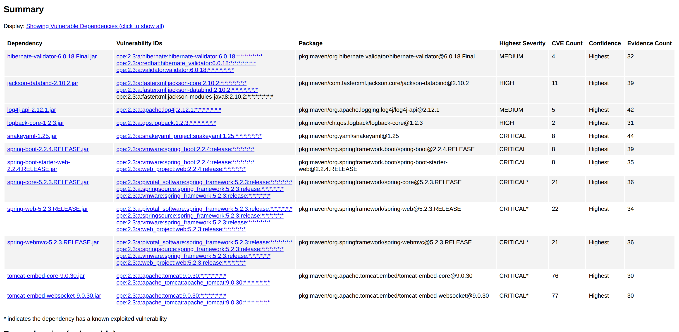
Figure 2. Summary of the twelve vulnerable dependencies, with matched CPEs and CVE counts.
Tool configuration note. The first run failed with repeated HTTP 401 responses from the Sonatype OSS Index analyzer, which now requires registered credentials. Because every one of those requests failed, that analyzer contributed no findings, and I disabled it with -DossindexAnalyzerEnabled=false. The scan is therefore scoped to the National Vulnerability Database, the authoritative public source. The counts above are unchanged by this; only the Analysis Exceptions section disappeared.

Document Results

The project declares three direct dependencies — spring-boot-starter-web, spring-boot-starter-test, and mongo-java-driver 2.4 — but the Spring Boot 2.2.4.RELEASE parent resolves 38 dependencies (23 unique). Twelve are flagged, carrying 263 findings between them. The descriptions below cover the significant CVEs verified against the NVD and vendor advisories; the complete per-dependency CVE lists are in the report itself.
Dependency | CVEs | Severity | Verified representative findings
hibernate-validator-6.0.18.Final.jar | 4 | Medium | CVE-2020-10693 (5.3): a flaw in constraint-message interpolation evaluates invalid EL expressions as valid, letting an attacker bypass sanitization applied to validation error messages.
jackson-databind-2.10.2.jar | 11 | High | CVE-2020-25649 (7.5): entity expansion is not secured, exposing the XML data-binding path to XXE. CVE-2020-36518 (7.5): deeply nested JSON triggers a StackOverflowError, denying service on any endpoint accepting JSON.
log4j-api-2.12.1.jar | 5 | Medium | The api artifact is a thin logging facade. Log4Shell (CVE-2021-44228) lives in log4j-core, which this build does not ship, and is correctly absent from the report.
logback-core-1.2.3.jar | 2 | High | CVE-2021-42550 (6.6): a crafted logback configuration can load and execute arbitrary code from a remote LDAP server. Requires privileges to edit configuration files.
snakeyaml-1.25.jar | 8 | Critical | CVE-2022-1471 (9.8): the default Constructor does not restrict which types may be instantiated, so parsing attacker-supplied YAML yields remote code execution. CVE-2017-18640 (7.5): unbounded alias expansion ("billion laughs") exhausts memory.
spring-boot-2.2.4.RELEASE.jar | 8 | Critical | Spring Boot 2.2.x reached end of life in 2020 and receives no security backports; the eight findings here are cumulative across that abandonment.
spring-boot-starter-web-2.2.4.RELEASE.jar | 8 | Critical | The same eight CVEs as spring-boot above. This artifact is a dependency aggregator with essentially no code of its own — see the false-positive discussion under Analyze Results.
spring-core-5.2.3.RELEASE.jar | 21 | Critical * | CVE-2022-22965 (9.8, "Spring4Shell"): remote code execution through data binding on JDK 9+ when deployed as a WAR on Tomcat; class-loader manipulation lets an attacker write a JSP web shell.
spring-web-5.2.3.RELEASE.jar | 22 | Critical * | The spring-core set plus CVE-2016-1000027, a deserialization flaw specific to this artifact’s HTTP invoker support.
spring-webmvc-5.2.3.RELEASE.jar | 21 | Critical * | Identical CVE set to spring-core: all four Spring Framework JARs resolve to the same spring_framework CPE and therefore inherit the same list.
tomcat-embed-core-9.0.30.jar | 76 | Critical * | CVE-2020-1938 (9.8, "Ghostcat"): the AJP connector, enabled by default on all interfaces, lets an attacker read arbitrary files in the web application and process any uploaded file as a JSP. CVE-2020-9484 (7.0): deserialization of untrusted data during FileStore session persistence permits code execution.
tomcat-embed-websocket-9.0.30.jar | 77 | Critical * | Shares the Tomcat CPE with tomcat-embed-core and therefore inherits its findings, although most describe defects in core HTTP, AJP and session handling rather than the WebSocket module.
* marks a dependency the report identifies as carrying a known exploited vulnerability — one with confirmed exploitation in the wild, not merely a published advisory. Six of the twelve carry this flag.

Analyze Results

The risk concentrates in two places. Tomcat accounts for 153 of the 263 findings across its two JARs, and the Spring Framework for another 64 across its four. Both Ghostcat (CVE-2020-1938) and Spring4Shell (CVE-2022-22965) carry a CVSS v3.1 base score of 9.8, are network-reachable without authentication, and have public working exploits. Neither can be mitigated in application code; both are fixed only by upgrading. Fortunately one action addresses nearly everything at once.
• Raise the Spring Boot parent version. Moving spring-boot-starter-parent from 2.2.4.RELEASE to a currently supported 3.x release re-resolves Spring Framework, Tomcat, Jackson, SnakeYAML, Logback, Hibernate Validator and Log4j in one edit, clearing the overwhelming majority of the 263 findings. It is a breaking change — Java 17 baseline, jakarta.* namespace — so it belongs on a branch behind the full test suite.
• If that upgrade cannot be scheduled, pin the patched libraries. Spring Boot manages transitive versions through properties, so overriding spring-framework.version, tomcat.version, jackson-bom.version, snakeyaml.version, logback.version and hibernate-validator.version raises them without moving the parent. This is a stopgap: 2.2.x reached end of life in 2020 and receives no backports, so the debt returns with the next disclosure.
• Replace mongo-java-driver 2.4 despite its clean result. The driver was scanned and reported zero vulnerabilities. That is not evidence of safety. It was published in December 2010, MongoDB no longer maintains it, and an unmaintained artifact accrues no CVEs precisely because nobody is auditing it. Absence of findings on an abandoned library is a false-negative risk, not a clean bill of health; the vendor directs users to mongodb-driver-sync.
• Make the check enforcing rather than advisory. Binding the goal to the build lifecycle with a failBuildOnCVSS threshold converts this from a one-time report into a gate, so a contributor cannot reintroduce a critical dependency without the build stopping.
Prioritization should follow exploitability rather than raw counts. The six dependencies flagged with known exploited vulnerabilities come first, and within those, Ghostcat and Spring4Shell before anything else. The Logback and Hibernate Validator issues require an attacker to already hold configuration-edit privileges or to reach a constraint-violation message path, which makes them real but secondary.

Filtering False Positives
Dependency-check does not read code; it infers identity. It derives evidence from a JAR’s file name, manifest and POM metadata, guesses matching CPEs, and reports every CVE registered against them. When a guess is wrong, so is the finding — and this report contains clear examples in its own CPE column.
• hibernate-validator is matched to cpe:2.3:a:validator:validator:6.0.18 — a product literally named "validator" from a vendor named "validator", alongside the two correct Hibernate CPEs. That is a version-number coincidence, not an identification.
• spring-boot-starter-web, spring-web and spring-webmvc all carry cpe:2.3:a:web_project:web — a product whose name is the single word "web". Any CVE filed against it lands on three of this project’s JARs.
• Both Tomcat JARs carry cpe:2.3:a:apache:tomcat and cpe:2.3:a:apache_tomcat:apache_tomcat — the same product under two identities, which double-counts findings.
• The jackson-databind JAR is additionally matched to jackson-core and jackson-modules-java8 CPEs, which are separate artifacts shipping as their own JARs on this classpath.
Structural duplication inflates the number further. All four Spring Framework JARs resolve to one spring_framework CPE and inherit an identical 21-CVE list; tomcat-embed-websocket inherits 77 findings from the Tomcat CPE even though most describe defects in core HTTP, AJP and session handling rather than the WebSocket module; and spring-boot-starter-web, an aggregator POM with essentially no code, inherits all eight spring-boot findings. So 263 is an upper bound on reported findings, not a count of distinct exploitable defects in this application. Deduplicating the Spring and Tomcat families alone collapses a large share of it.
Filtering matters for three reasons. Remediation effort is finite, and time spent chasing a CVE filed against a product called "web" is time not spent upgrading Tomcat. Unfiltered noise erodes trust in the tool, and a report developers have learned to skim is a report that will hide the next real critical finding. And if the scan is wired into CI with a failure threshold, false positives break builds that should have passed, which pressures the team into disabling the gate altogether — the worst possible outcome.
The correct handling is verification, then suppression with a written justification. Each finding is checked against the affected-version range on its NVD or vendor advisory page and against what the library actually does; confirmed non-issues go into a dependency-check-suppression.xml committed alongside the pom, with a notes element recording who validated it and when. The scan information reports Vulnerabilities Suppressed: 0, which is an honest statement that no triage has been performed yet — that number rising, with justifications attached, is what progress looks like here.

References
Apache Software Foundation. (2020). Apache Tomcat 9 vulnerabilities. https://tomcat.apache.org/security-9.html
MongoDB, Inc. (n.d.). mongo-java-driver 2.4. Maven Repository. https://mvnrepository.com/artifact/org.mongodb/mongo-java-driver/2.4
National Institute of Standards and Technology. (2019). CVE-2017-18640 detail. National Vulnerability Database. https://nvd.nist.gov/vuln/detail/CVE-2017-18640
National Institute of Standards and Technology. (2020a). CVE-2020-10693 detail. National Vulnerability Database. https://nvd.nist.gov/vuln/detail/CVE-2020-10693
National Institute of Standards and Technology. (2020b). CVE-2020-1938 detail. National Vulnerability Database. https://nvd.nist.gov/vuln/detail/CVE-2020-1938
National Institute of Standards and Technology. (2020c). CVE-2020-25649 detail. National Vulnerability Database. https://nvd.nist.gov/vuln/detail/CVE-2020-25649
National Institute of Standards and Technology. (2020d). CVE-2020-9484 detail. National Vulnerability Database. https://nvd.nist.gov/vuln/detail/CVE-2020-9484
National Institute of Standards and Technology. (2021). CVE-2021-42550 detail. National Vulnerability Database. https://nvd.nist.gov/vuln/detail/CVE-2021-42550
National Institute of Standards and Technology. (2022a). CVE-2020-36518 detail. National Vulnerability Database. https://nvd.nist.gov/vuln/detail/CVE-2020-36518
National Institute of Standards and Technology. (2022b). CVE-2022-1471 detail. National Vulnerability Database. https://nvd.nist.gov/vuln/detail/CVE-2022-1471
National Institute of Standards and Technology. (2022c). CVE-2022-22965 detail. National Vulnerability Database. https://nvd.nist.gov/vuln/detail/CVE-2022-22965
OWASP Foundation. (n.d.). OWASP dependency-check. https://owasp.org/www-project-dependency-check/
VMware Tanzu. (2022). CVE-2022-22965: Spring Framework RCE via data binding on JDK 9+. https://spring.io/security/cve-2022-22965

